# Data Flow Diagram & User Stories

|  |  |
| --- | --- |
| Date | 17 October 2022 |
| Team ID | PNT2022TMID11482 |
| Project Name | Project – Corporate Employee Attrition Analysis |
| Maximum Marks | 4 Marks |

## Data Flow Diagrams:

A Data Flow Diagram (DFD) is a traditional visual representation of the information flows within a system. A neat and clear DFD can depict the right amount of the system requirement graphically. It shows how data enters and leaves the system, what changes the information, and where data is stored.

Example: DFD Level 0 (Industry Standard)

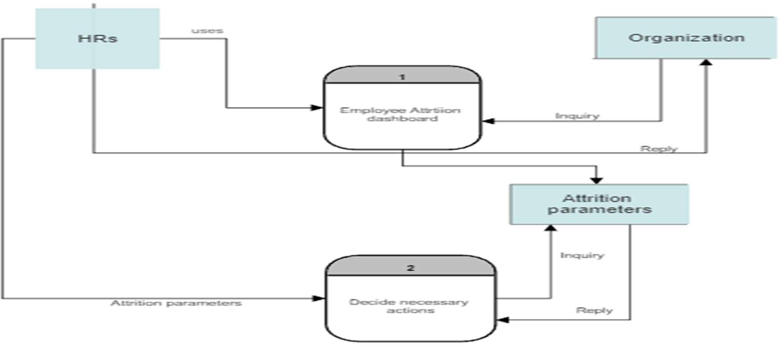

# User Stories

**Corporate Employee Attrition Analysis**

## User Stories

Use the below template to list all the user stories for the product.

|  |  |  |  |  |  |  |
| --- | --- | --- | --- | --- | --- | --- |
| **User Type** | **Functional Requirement (Epic)** | **User Story Number** | **User Story / Task** | **Acceptance criteria** | **Priority** | **Release** |
| Employees | Registration | USN-1 | The employees can register to be a part of the organisation by entering in form and getting authenticated via email. | I can access my account / dashboard | High | Sprint-1 |
|  |  | USN-2 | As an employee, I will receive confirmation  email once I have registered for the application | I can receive confirmation  email & click confirm | High | Sprint-1 |
|  |  | USN-3 | As an employee, I can register for the application through Facebook | I can register & access the dashboard with Facebook  Login | Low | Sprint-1 |
|  |  | USN-4 | As an employee, I can register for the application through Gmail | I can get a verification link through email | Medium | Sprint-1 |
|  | Login | USN-5 | As a employee, I can log into the application by entering email & password | I can enter the application | High | Sprint-2 |
|  | About | USN-6 | I can click on the “About” to get the idea on employee attrition rate prediction using parameters like work environment, sentiments of employee, daily employee engagement and  work progress. | I can get an idea about the project | Low | Sprint-2 |
|  | Launch | USN-7 | As a HR, I can upload various analysed parameters from the computer. | I can choose any employee (‘s all parameters) from my device | High | Sprint-2 |
|  | Predict | USN-8 | As a HR, I can perform prediction using predict button | I can view the employee’s parameters on the dashboard along with the attrition rate. | High | Sprint-3 |
|  |  | USN-9 | I can also upload csv format of employee retention parameters from cloud. | I can view the employee’s parameters on the | Medium | Sprint-3 |

|  |  |  |  |  |  |  |
| --- | --- | --- | --- | --- | --- | --- |
| **User Type** | **Functional Requirement**  **(Epic)** | **User Story Number** | **User Story / Task** | **Acceptance criteria** | **Priority** | **Release** |
|  |  |  |  | dashboard along with the attrition rate. |  |  |